**Assignment number 2**

**Name: Aamna Zahid**

**Reg. No: Fa20-bcs-151**

**Subject: Compiler Construction**

**Sub. To: Mam Sana Aslam**

**Date: 18 March 2024**

**Question:You’re tasked to implementing the given grammar and declare that the grammar is LL(1) or not also generate a LL(1) parse table for the given grammar, don’t forget to find firsts and follows before parsing.**

**S → AB |e D a**

**A → ab |c**

**B → d C**

**C → e C | €**

**D → f D | €**

**Implementation:  
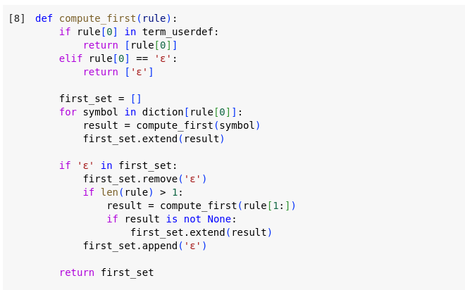**

**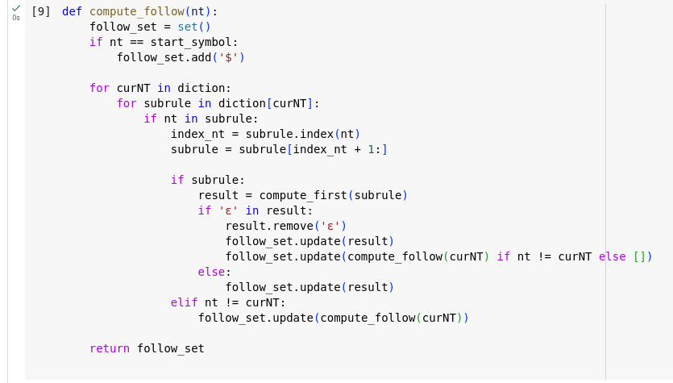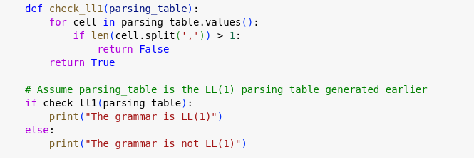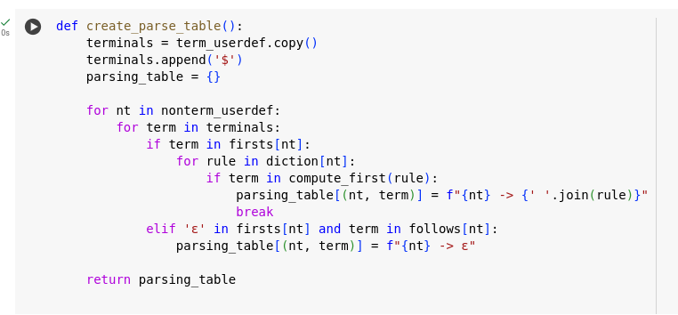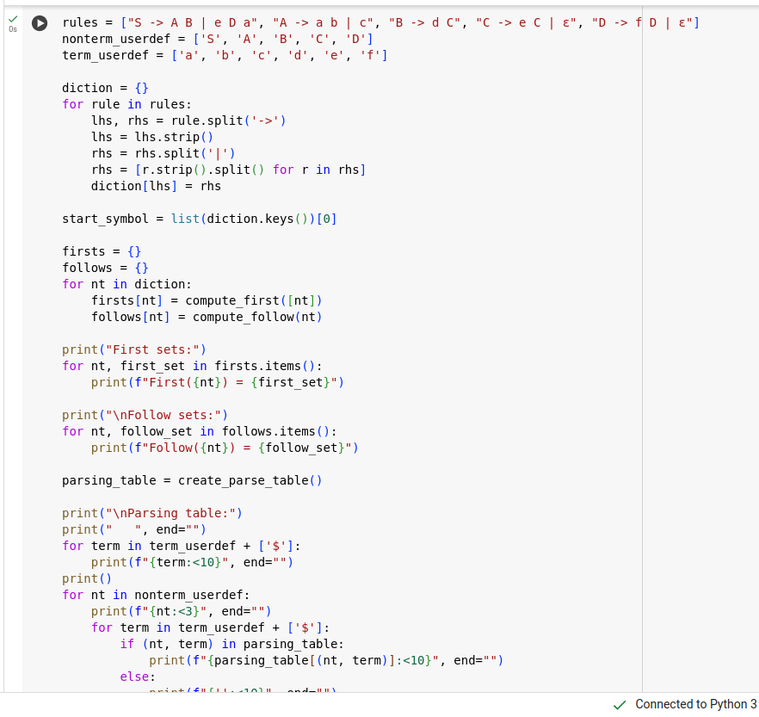  
Output:**

